Housing report says migration may need to be cut to preserve quality of life
Grattan Institute says population policy needed that will set ‘appropriate’ level of migration
Gareth Hutchens
@grhutchens Email Sun 4 Mar 2018 21.00 AEDT Last modified on Mon 10 Dec 2018 11.36 AEDT

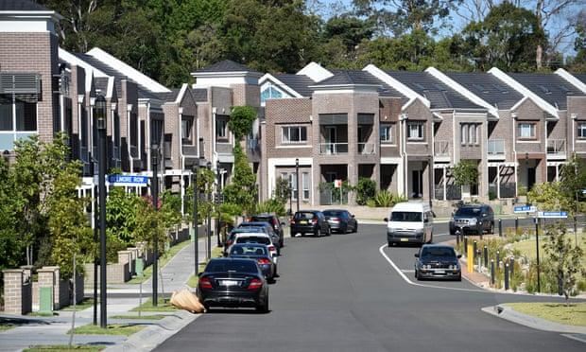
The Grattan Institute says the Coalition needs to take seriously the degree to which Sydney and Melbourne are struggling to cope with high population growth. Photograph: Dan Himbrechts/AAP
One of Australia’s most respected thinktanks has weighed into the population growth debate, saying the federal government needs to develop an explicit population policy that defines the “appropriate” level of migration, and it may need to reduce the migrant intake to improve wellbeing.
The Grattan Institute says it is wading into the debate cautiously and it has deliberately not identified an optimum level of migration.
But it says the Turnbull government needs to take seriously the degree to which major cities, particularly Sydney and Melbourne, are struggling to cope with high population growth.

Tony Abbott to call for immigration cut in speech targeting political elites
It says if state governments continue to fail to increase the supply of housing and infrastructure necessary to keep pace with rapid population growth, then the federal government may have to reduce the migrant intake so the quality of life of residents in New South Wales and Victoria – and other states – does not get worse.
The Grattan Institute’s recommendation can be found in a new research report on housing affordability, Re-imagining the Australian Dream, which was released on Sunday evening.
The 177-page report contains 13 policy recommendations the institute says will improve housing affordability in Australia.
It comes two weeks after the former prime minister Tony Abbott reignited debate about Australia’s population growth by calling for the permanent migration intake to be slashed by 80,000 places a year, from 190,000 to 110,000.
Abbott had seized on comments from the home affairs minister, Peter Dutton, who told 2GB Radio in mid-February that it was a “perfectly legitimate argument” that Australia’s cities were “overcrowded”, including “gridlocked traffic in the mornings”, and that the government would review the migration intake if it was in the national interest.
Abbott used Dutton’s comments as a springboard to say that, despite concerns about housing affordability, “no one on the frontbench of government or opposition had been prepared to raise the one big contributing factor that is wholly and solely within the federal government’s control”.
But Abbott’s senior Coalition colleagues criticised his foray, including past and present immigration ministers, the acting prime minister and the trade minister.
Dutton clarified that his comment in mid-February “wasn’t a departure from what I’ve said previously” and that the Turnbull government “has got the settings right”.
John Daley from the Grattan Institute told Guardian Australia he was very conscious of the politics surrounding population growth and he did not want to be seen to be calling for the migrant intake to be cut.
He said his priority was housing affordability, the causes of high house prices and Australians’ living standards.
He said federal and state governments had numerous policy levers available to them to make houses more affordable, including limiting negative gearing, slashing the capital gains discount from 50% to 25%, changing the age pension assets test to include the value of a home above a certain threshold (such as $500,000), extending state land taxes to owner occupied housing, and setting housing targets at a state level and making sure local governments meet them.

Tony Abbott repeats claim immigration cut will improve quality of life
Read more
But he said the Grattan Institute also believed state governments were struggling to deal with rapid population growth in their major cities and the quality of life of residents – represented by the rapid growth in house prices in recent decades – was suffering.
House prices have more than doubled in real terms over the past 20 years, with the strains most acute in Sydney and Melbourne. Since 2012, house prices have risen 50% in Melbourne and 70% in Sydney.
“The commonwealth government should develop an explicit population policy,” the Grattan Institute report says. “[It should] articulate the appropriate level of migration given evidence of the impact of migration on the wellbeing of the Australian community, accounting for both actual and optimal infrastructure and land use planning policies.
“[And] if planning and infrastructure policies do not improve, consider reducing Australia’s current migrant intake.
“Reducing immigration would reduce demand but it would also reduce economic growth per existing resident [so] first-best policy is probably to continue with Australia’s demand-driven, relatively high-skill migration, and to increase supply of housing accordingly.
“But Australia is currently in a world of third-best policy: rapid migration, and restricted supply of housing, which is imposing big costs on those who have not already bought housing. If states are not going to improve supply [of housing] ... then the commonwealth should consider reducing migration as the lesser evil.”
In his book Choosing Openness, Labor’s shadow assistant treasurer, Andrew Leigh, noted that, according to an OECD survey of academic studies, migrants had minimal impact on housing prices.
Of the OECD’s 28 studies on immigration and wages, 13 reported no effect, seven a small positive effect, and eight a small negative effect, he said.
https://www.theguardian.com/australia-news/2018/mar/04/housing-report-says-migration-may-need-to-be-cut-to-preserve-quality-of-life

